Programmer: _____________
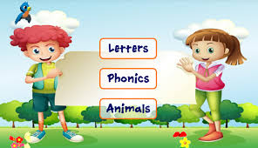 ICS201 - Final Evaluation – Marking Rubric 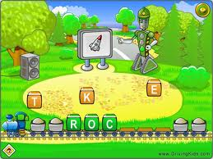

Criteria | Level 1 (50-59) | Level 2 (60-69) | Level 3 (70-79) | Level 4 (80-100)
Program Description ( /5) | - Title is absent or non descriptive and description doesn’t provide adequate information to the user about the program (2.5 – 3) | - Title is present and description provides satisfactory information to the user about the program (3- 3.5) | - A good title is present and description provides all information to the user about the program (3.5-4) | - A good title is present and description provides detailed information to the user to purchase the program 4-5)
Flowchart (Thinking and Inquiry) /15 | - incomplete algorithm providing minimal steps lacking required detail to solve the problem | - Algorithm provides adequate steps in minimal detail to solve the problem | - Algorithm provides all required steps in good detail to solve the problem | - Algorithm provides all steps in great detail to solve the problem.
Programming Task and Skills to be demonstrated  ( /100) | Comic Strip  - minimum of three frames  - one must be animated  - use readkey for transition to next frame  - use a variety of shapes  - user must make a choice  - must show input, output, selection and repetition at the Level 1 Skill Level.  Extras: | Math Quiz Show  - a graphical math quiz  - 7 questions using only addition OR subtraction  - Use of constants, random numbers, and scoring  - graphical questions & reward  - must allow the user to try the test again  - must show input, output, selection and repetition at the Level 2 Skill Level.  Extras: | Math Quiz Show-DELUXE  - Level 3 plus  - a Menu including a choice of addition, subtraction and multiplication with three questions for each operation  - use of randomly numbers  - must not allow negatives  - must show input, output, selection and repetition at the Level 3 Skill Level.  Extras: | Math and English Language Learning Game  - Level 3 plus (animation/GFX)  - provides the choice to play the Math or the ELL game  - Creatively assesses a selected literacy skill  - Incorporates: Mouse routines for user interface  - Optional use of Sound (oral instructions)  - Demonstrates programming skills at the level 4  Extras:
Programming Style /10  ( /5)  (/ 5) | - Incomplete header, indenting, spacing and documentation  - Incomplete instructions and user prompts | - Basic header indenting, spacing and documentation  - Instructions and user prompts require more clarity | - Header, indenting, spacing and documentation are well done.  - Instructions and user prompts are clear and easy to follow | - Header, indenting, spacing and documentation are very well done.  - Instructions and user prompts are well done with: clarity, creativity and added visual interest
Total: /130

